8MP WDR LightHunter VF Eyeball Network IR Camera
IPC3638SR3-DPZ

Key Features
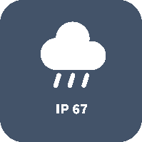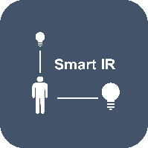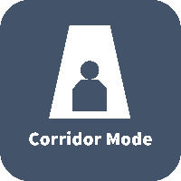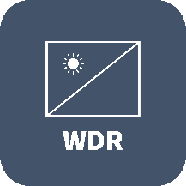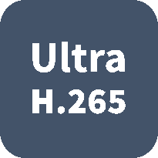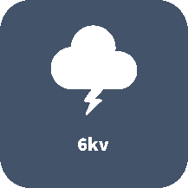

Optics
- LightHunter
- Day/night functionality
- Optical glass window with higher light transmittance
- IR anti-reflection window to increase the infrared transmittance
- Smart IR, up to 30m (98ft) IR distance
- Up to 120dB Optical WDR (Wide Dynamic Range)
- 2D/3D DNR (Digital Noise Reduction)

Compression
- Ultra 265, H.265, H.264, MJPEG
- Triple streams
- ROI (Region of Interest)
- 9:16 corridor mode

Network
- ONVIF Conformance

Structure
- Support PoE power supply
- Wide temperature range: -40°C ~ 60°C (-40°F ~ 140°F)
- Wide voltage range of ±25%
- IP67
- 3-Axis

Specifications
 | IPC3638SR3-DPZ
Camera
Sensor | 1/2", 8.0 megapixel, progressive scan, CMOS
Lens | 2.8 ~ 12mm, AF automatic focusing and motorized zoom lens
DORI Distance | Lens (mm) |  | Detect (m) |  | Observe (m) | Recognize (m) |  | Identify (m)
 | 2.8 |  | 63 |  | 25.2 | 12.6 |  | 6.3
 | 12 |  | 270 |  | 108 | 54 |  | 27
Angle of view (H) | 114.8° ~ 47.3°
Angle of View (V) | 75.3° ~ 20.4°
Angle of View (O) | 141.2° ~ 55.8°
Adjustment angle | Pan: 0° ~ 360° |  |  | Tilt: 0° ~ 90° |  |  | Rotate: 0° ~ 360°
Shutter | Auto/Manual, 1 ~ 1/100000s
Minimum Illumination | Colour: 0.001Lux (F1.5, AGC ON)  0Lux with IR
Day/Night | IR-cut filter with auto switch (ICR)
S/N | >52dB
IR Range | Up to 30m (98ft) IR range
wavelength | 850nm
IR On/Off Control | Auto/Manual
Defog | Digital Defog
WDR | 120dB
Video
Video Compression | Ultra 265, H.265, H.264, MJPEG
Frame Rate | Main Stream: 8MP (3840*2160), Max 20fps; 5MP (2592*1944), Max 30fps; 5MP (2944*1656), Max 30fps;  4MP (2560*1440), Max 30fps; 2MP (1920*1080), Max 60fps;  Sub Stream: 2MP (1920*1080), Max 30fps;  Third Stream: D1 (720*576), Max 30fps
Video Bit Rate | 128 Kbps~16 Mbps
9:16 Corridor Mode | Supported
OSD | Up to 8 OSDs
Privacy Mask | Up to 8 areas
ROI | Up to 8 areas
Motion Detection | Up to 4 areas
Image
White Balance |  | Auto/Outdoor/Fine Tune/Sodium Lamp/Locked/Auto2
Digital noise reduction |  | 2D/3D DNR
Smart IR |  | Support
Flip |  | Normal/Vertical/Horizontal/180°/90°Clockwise/90°Anti-clockwise
Dewarping |  | Support
HLC |  | Support
BLC |  | Support
Audio
Audio Compression | G.711
Suppression | Supported
Sampling Rate | 8KHZ
Storage
Edge Storage | Micro SD, up to 256GB
Network Storage | ANR, NAS(NFS)
Network
Protocols | IPv4, IGMP, ICMP, ARP, TCP, UDP, DHCP, PPPoE, RTP, RTSP, RTCP, DNS, DDNS, NTP, FTP, UPnP, HTTP, HTTPS, SMTP, 802.1x, SNMP, QoS
Compatible Integration | ONVIF (Profile S, Profile G, Profile T), API
Client | EZStation  EZView  EZLive
Web Browser | Plug-in required live view: IE9+, Chrome 41 and below, Firefox 52 and below
 | Plug-in free live view: Chorme 57.0+, Firefox 58.0+, Edge 16+, Safari 11+
Interface
Built-in Mic | Supported
Network | 1 RJ45 10M/100M Base-TX Ethernet
Certifications
Certifications |  | CE: EN 60950-1  UL: UL60950-1  FCC: FCC Part 15
General
Power | DC 12V±25%, PoE (IEEE 802.3af)
 | Power consumption: Max 8.16W
Dimensions (Ø x H) | Φ129 x 110mm (Ø5.08” x 4.3”)
Net Weight | 0.82kg (1.8lb)
Material | Metal
Working Environment | -40°C ~ 60°C (-40°F ~ 140°F), Humidity: ≤95% RH (non-condensing)
Strorage Environment | -40°C ~ 60°C (-40°F ~ 140°F), Humidity: ≤95% RH (non-condensing)
surge protection | 6KV
Reset Button | Supported
Ingress Protection | IP67

Dimensions
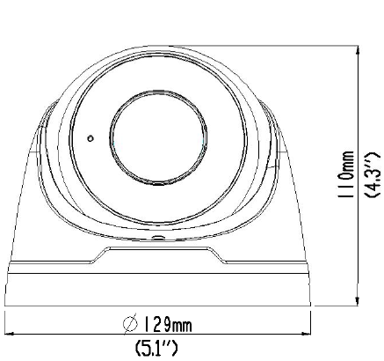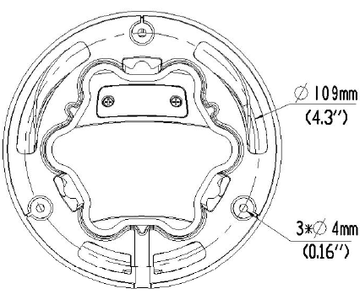

Accessories
TR-JB03-H-IN | TR-JB07/WM03-F-IN | TR-WM03-B-IN | TR-A01-IN
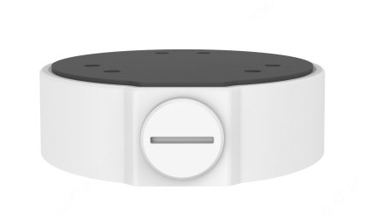 | 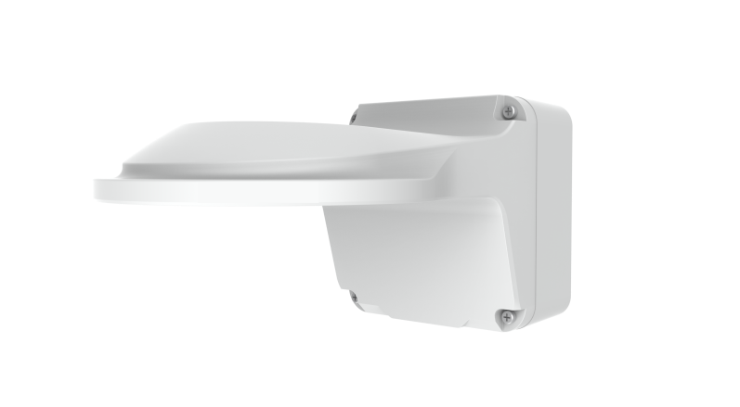 |  | 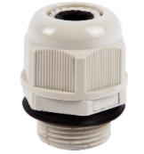
TR-UP06-IN | TR-SE24-IN | TR-SE24-A-IN | TR-CM24-IN
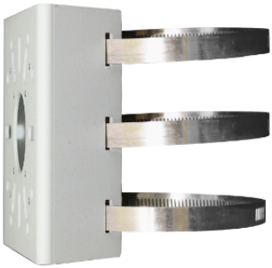

Junction box | Pole mount
TR-JB03-H-IN+TR-A01-IN | TR-JB07/WM03-F-IN (TR-WM03-B-IN)+ TR-UP06-IN
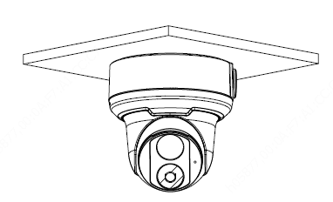 | 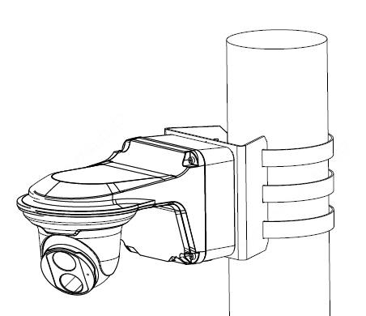
Indoor pendent mount
TR-JB04-D-IN+TR-A01-IN+ TR-SE24-IN(TR-SE24-A-IN)+ TR-CM24-IN
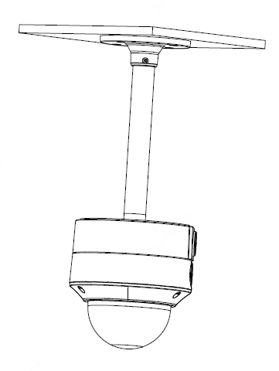

Zhejiang Uniview Technologies Co., Ltd.
Building No.10, Wanlun Science Park, Jiangling Road 88, Binjiang District, Hangzhou, Zhejiang, China (310051)
Email: overseasbusiness@uniview.com; globalsupport@uniview.com
http://www.uniview.com
©2019 Zhejiang Uniview Technologies Co., Ltd. All rights reserved.
*Product specifications and availability are subject to change without notice.

